DONE:

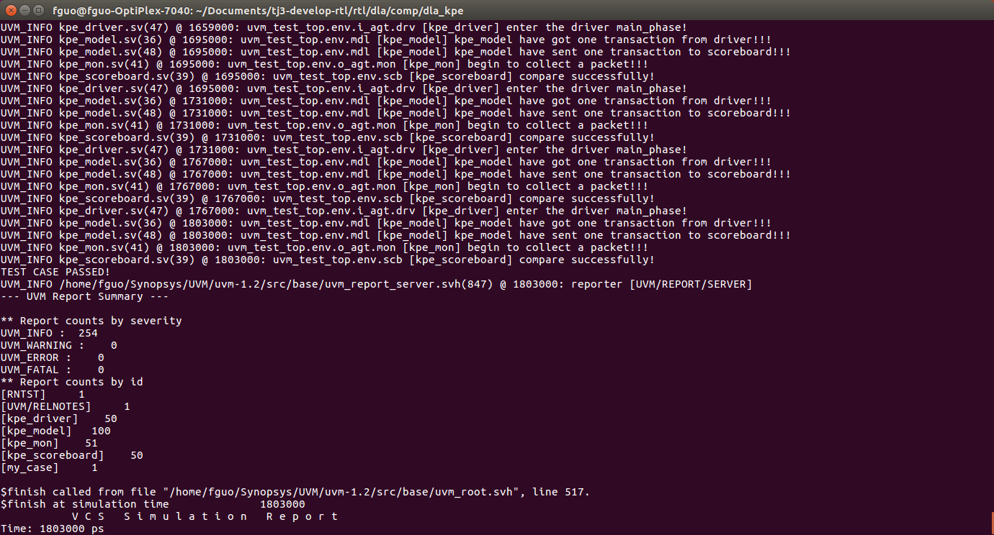1.Complete the verification of whole KPE in 16-bit mode.

The 8-bit mode has not being verified. It still has some errors.

TO DO:

1.Complete the rest of KPE.

2.Verify the LPE.